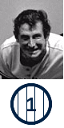
MARTIN Billy

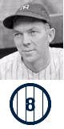
DICKEY Bill

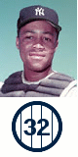
HOWARD ELSTON


JETER Derek

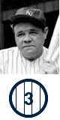
RUTH Babe

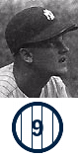
MARIS Roger

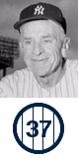
STENGEL Casey

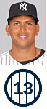
RODRIGUEZ Alex

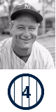
GEHRIG Lou

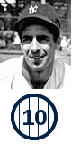
RIZZUTO Phil

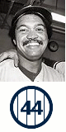
JACKSON Reggie

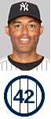
RIVERA Mariano

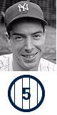
DiMAGGIO Joe

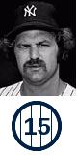
MUNSON Thurman

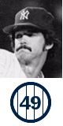
GUIDRY Ron

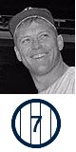
MANTLE Mickey

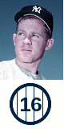
FORD Whitey

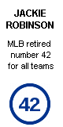
ROBINSON Jackie

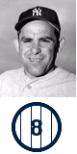
BERRA Yogi

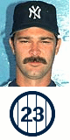
MATTINGLY Don

